VISVESVARAYA TECHNOLOGICAL UNIVERSITY
“JnanaSangama”, Belgaum -590014, Karnataka.

LAB REPORT
On

DATA STRUCTURES (23CS3PCDST)

Submitted by

PANCHANGAM SATHYA HAMSINI (1BF24CS208)

in partial fulfillment for the award of the degree of
BACHELOR OF ENGINEERING
in
COMPUTER SCIENCE AND ENGINEERING



B.M.S. COLLEGE OF ENGINEERING
(Autonomous Institution under VTU)
BENGALURU-560019
August-December 2025

B. M. S. College of Engineering,
Bull Temple Road, Bangalore 560019
(Affiliated To Visvesvaraya Technological University, Belgaum)
Department of Computer Science and Engineering



This is to certify that the Lab work entitled “DATA STRUCTURES” carried out by PANCHANGAM SATHYA HAMSINI (1BF24CS208), who is a bonafide student of B. M. S. College of Engineering. It is in partial fulfillment for the award of Bachelor of Engineering in Computer Science and Engineering of the Visvesvaraya Technological University, Belgaum during the year 2025-2026. The Lab report has been approved as it satisfies the academic requirements in respect of Data structures Lab - (23CS3PCDST) work prescribed for the said degree.

Anusha S Dr. Kavitha Sooda
Assistant Professor Professor and Head
Department of CSE Department of CSE
BMSCE, Bengaluru BMSCE, Bengaluru

Index Sheet
Sl.  No. | Experiment Title | Page No.
1 | Stack Operations- Push, Pop, Display | 5
2 | - Infix to Postfix | 7
3 | - Queue Operations- Insert, Delete, Display  - Circular Queue Operations- Insert, Delete, Display | 9
4 | - Singly Linked List- Create, Insertion, Display  - Leetcode | 16
5 | - Singly Linked List- Create, Deletion, Display  - Leetcode | 23
6 | - Singly Linked List operations- Sort, Reverse, Concatenation  - Stack and Queue operations | 31
7 | - Doubly Linked List- Create, Insertion, Deletion, Display  - Leetcode | 48
8 | - Binary Search Tree- Construct, Inorder Preorder Postorder, Display  - Leetcode | 53
9 | - Write a program to traverse a graph using the BFS method.  - Write a program to check whether given graph is  connected or not using the DFS method. | 55
10 | Linear Probing (Hash Table) | 62

Course outcomes:
CO1 | Apply the concept of linear and nonlinear data structures.
CO2 | Analyze data structure operations for a given problem
CO3 | Design and develop solutions using the operations of linear and nonlinear data structure for a given specification.
CO4 | Conduct practical experiments for demonstrating the operations of different data structures.

Lab program 1:
Write a program to simulate the working of stack using an array with the following:
a) Push
b) Pop
c) Display
The program should print appropriate messages for stack overflow, stack underflow.
Code:
#include<stdio.h>
#define N 5
int stack[N];
int top=-1;
void push(){
int x;
printf("Enter data: ");
scanf("%d",&x);
if (top==N-1){
printf("Stack Overflow\n");
}
else{
top++;
stack[top]=x;
}
}

void pop(){
if (top==-1) printf("Stack Underflow\n");
else{
printf("Item deleted= %d\n",stack[top]);
top--;
}
}

void peek(){
if (top==-1) printf("Stack Empty\n");
else printf("Item at the top= %d\n",stack[top]);
}

void display(){
if (top==-1) printf("Stack Empty\n");
else{
for (int i=0;i<N;i++){
printf("%d\n",stack[i]);
}
}
}
void main(){
int ch;
do{
printf("Choose from the following options: 1-push, 2-pop, 3-peek, 4-display, 5-exit\n");
scanf("%d",&ch);
switch (ch){
case 1:
push();
break;
case 2:
pop();
break;
case 3:
peek();
break;
case 4:
display();
break;
default:
printf("Invalid\n");
}
}while(ch!=5);
}

Output:

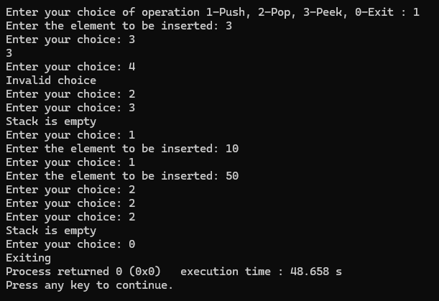

Lab program 2:
- WAP to convert a given valid parenthesized infix arithmetic expression to postfix expression. The expression consists of single character operands and the binary operators + (plus), - (minus), * (multiply) and /(divide).

Code:

#include<stdio.h>
#include<ctype.h>
#include<string.h>
#define MAX 100
char stack[MAX];
int top=-1;
int precedence(char o){
if (o=='+' || o=='-') return 1;
else if (o=='*' || o=='/') return 2;
else if (o=='^') return 3;
else if (o=='(') return 0;
}
int associativity(char o){
if (o=='^') return 1;
else return 0;
}
void push(char x){
if (top==MAX-1){
printf("Stack overflow\n");
return;
}
stack[++top]=x;
}
char pop(){
if (top==-1){
printf("Stack is empty\n");
return -1;
}
return stack[top--];
}
char peek(){
if (top==-1) printf("Stack is empty\n");
return stack[top];
}
void infixtopostfix(char infix[],char postfix[]){
int p=0;
char ch;
for (int i=0;i<strlen(infix);i++){
ch=infix[i];
if (isalnum(ch)) postfix[p++]=ch;
else if (ch=='(') push(ch);
else if (ch==')'){
while(peek()!='('){
postfix[p++]=pop();
}
pop();
}
else{
while(top!=-1 && ((precedence(peek())> precedence(ch))|| (precedence(peek())==precedence(ch) && associativity(ch)==0))){
postfix[p++]=pop();
}
push(ch);
}
}
while(top!=-1){
postfix[p++]=pop();
}
postfix[p]='\0';
}

int main(){
char infix[MAX],postfix[MAX];
printf("Enter a valid parenthesized infix expression: ");
scanf("%s",infix);
infixtopostfix(infix,postfix);
printf("The postfix expression is: %s\n",postfix);
return 0;
}

Outputs:

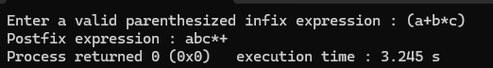
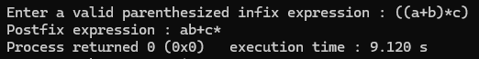
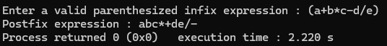
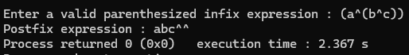

Lab program 3:
- WAP to simulate the working of a queue of integers using an array. Provide the following operations: Insert, Delete, Display.
The program should print appropriate messages for queue empty and queue overflow conditions.
#include <stdio.h>
#define N 5
int front=-1;
int rear=-1;
int queue[N];
void enqueue(){
int x;
printf("Enter an element:");
scanf("%d",&x);
if (front==-1 && rear==-1){
front=rear=0;
queue[rear]=x;
}
else if(rear==N-1){
printf("Queue is full\n");
}
else{
rear++;
queue[rear]=x;
}
}
void dequeue(){
if (front==-1 && rear==-1){
printf("Queue is empty\n");
}
else if (front==rear){
printf("Dequeued element=%d\n",queue[front]);
front=rear=-1;
}
else{
printf("Dequeued element=%d\n",queue[front]);
front++;
}
}
void display(){
if (front==-1 && rear==-1){
printf("Queue is empty\n");
}
else{
printf("The elements in the queue are:\n");
for (int i=0;i<=rear;i++){
printf("%d\n",queue[i]);
}
}
}

int main(){
int c;
printf("Choose: 1.enqueue, 2.dequeue, 3.display, 4.exit\n");
scanf("%d",&c);
while(c!=4){
switch(c){
case 1:
enqueue();
break;
case 2:
dequeue();
break;
case 3:
display();
break;
default:
printf("Exit\n");
}
printf("Choose: 1.enqueue, 2.dequeue, 3.display, 4.exit\n");
scanf("%d",&c);
}
}
Output:
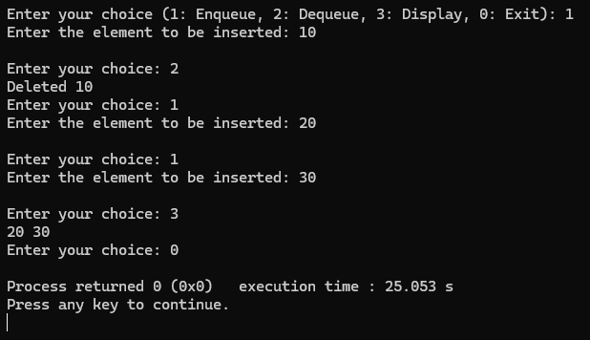

b ) WAP to simulate the working of a circular queue of integers using an array. Provide the following operations: Insert, Delete & Display.
The program should print appropriate messages for queue empty and queue overflow conditions.
Code:
#include<stdio.h>
#define N 5
int front=-1;
int rear=-1;
int queue[N];
void enqueue(){
int x;
printf("Enter an element: \n");
scanf("%d",&x);
if (front==-1 && rear==-1){
front=rear=0;
queue[rear]=x;
}
else if((rear+1)%N==front){
printf("Queue is full\n");
}
else{
rear=(rear+1)%N;
queue[rear]=x;
}
}
void dequeue(){
if (front==-1 && rear==-1){
printf("Queue is empty\n");
}
else if(front==rear){
printf("Dequeued element=%d\n",queue[front]);
front=rear=-1;
}
else{
printf("Dequeued element=%d\n",queue[front]);
front=(front+1)%N;
}
}
void display(){
printf("The elements are:\n");
if (front==-1 && rear==-1){
printf("Queue is empty\n");
return;
}
else{
if (front<rear){
for (int i=front;i<=rear;i++){
printf("%d\n",queue[i]);
}
}
else{
for (int i=front;i<N;i++){
printf("%d\n",queue[i]);
}
for (int i=0;i<=rear;i++){
printf("%d\n",queue[i]);
}
}

}
printf("\n");
}

int main(){
int c;
printf("Choose: 1.enqueue, 2.dequeue, 3.display, 4.exit\n");
scanf("%d",&c);
while(c!=4){
switch(c){
case 1:
enqueue();
break;
case 2:
dequeue();
break;
case 3:
display();
break;
case 4:
printf("Exit");
break;
default:
printf("Invalid\n");
}
printf("Choose: \n");
scanf("%d",&c);
}
}
Output:
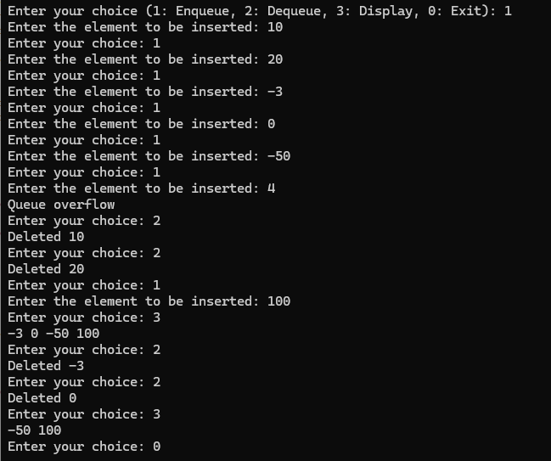

Lab program 4:
- WAP to Implement Singly Linked List with following operations:
a) Create a linked list.
b) Insertion of a node at first position, at any position and at end of list.
c) Display the contents of the linked list.
Code:
#include<stdio.h>
#include<stdlib.h>
struct Node{
int data;
struct Node *next;
};
struct Node *head=NULL,*newNode,*temp;

void createList(int n){
int data,i;
if (n<=0){
printf("List should be greater than 0 nodes.\n");
return;
}
for (i=1;i<=n;i++){
newNode=(struct Node*)malloc(sizeof(struct Node));
if (newNode==NULL){
printf("Memory allocation failed.\n");
return;
}
printf("Enter data for node %d: ",i);
scanf("%d",&data);
newNode->data=data;
newNode->next=NULL;
if (head==NULL){
head=newNode;
}
else{
temp->next=newNode;
}
temp=newNode;
}
}

void insertBegin(int data){
newNode=(struct Node*)malloc(sizeof(struct Node));
newNode->data=data;
newNode->next=head;
head=newNode;
printf("Node inserted at beginning.\n");
}

void inserEnd(int data){
newNode=(struct Node*)malloc(sizeof(struct Node));
newNode->data=data;
newNode->next=NULL;
if (head==NULL){
head=newNode;
}
else{
while(temp->next!=NULL){
temp=temp->next;
}
temp->next=newNode;
}
printf("Node inserted at end.\n");
}

void insertAtPos(int pos,int data){
newNode=(struct Node*)malloc(sizeof(struct Node));
temp=head;
if (pos<1){
printf("Invalid.\n");
return;
}
if (pos==1){
insertBegin(data);
return;
}
newNode->data=data;
for (int i=1;i<pos-1 && temp!=NULL;i++){
temp=temp->next;
}
if (temp==NULL){
printf("Position out of range.\n");
free(newNode);
}
else{
newNode->next=temp->next;
temp->next=newNode;
printf("Value entered at position: %d\n",pos);
}
}

void display(){
if (head==NULL){
printf("Empty list.\n");
return;
}
struct Node *temp=head;
printf("Linked List : \n");
while(temp-> next!=NULL){
printf("%d\n",temp->data);
temp=temp->next;
}
printf("%d\n",temp->data);
}

int main(){
int data,n,pos,ch;
while(1){
printf("Choose operation from the following to perform on singly linked list:\n");
printf("1. Create a linked list\n");
printf("2. Insert at beginning\n");
printf("3. Insert at end\n");
printf("4. Insert at a specific position\n");
printf("5. Display linked list\n");
printf("6. Exit \n");
scanf("%d",&ch);

switch(ch){
case 1:
printf("Enter no. of nodes: ");
scanf("%d",&n);
createList(n);
break;
case 2:
printf("Enter data to insert: ");
scanf("%d",&data);
insertBegin(data);
break;
case 3:
printf("Enter data: ");
scanf("%d",&data);
inserEnd(data);
break;
case 4:
printf("Enter data and position: ");
scanf("%d",&data);
scanf("%d",&pos);
insertAtPos(pos,data);
break;
case 5:
display();
break;
case 6:
printf("Exited");
break;
default:
printf("Invalid");
}
}
return 0;
}
Outputs:
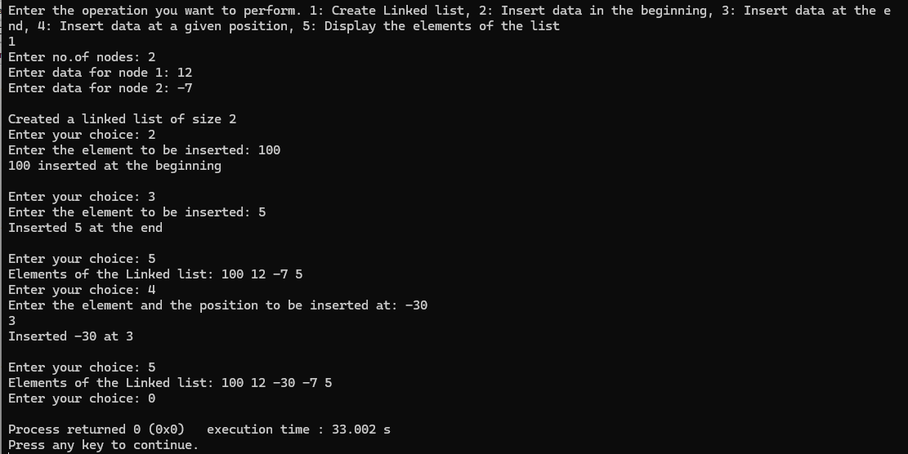
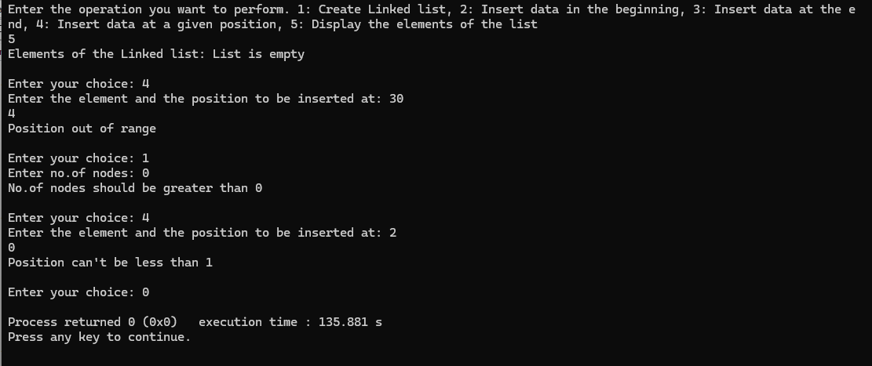
- Leetcode 876 (Middle of a Linked List)
Code:
struct ListNode* middleNode(struct ListNode* head) {
struct ListNode* temp=head;
if (head==NULL)
return NULL;
int count=0;
while (temp!=NULL)
{
count++;
temp=temp->next;
}
int mid=(count/2)+1;
temp=head;
for (int i=1;i<mid;i++)
{
temp=temp->next;
}
return temp;
}
Output:
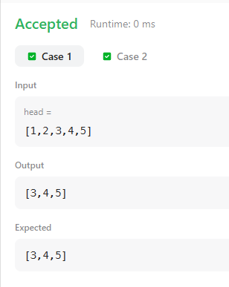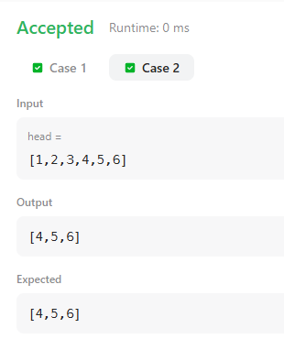
Lab program 5:
- WAP to Implement Singly Linked List with following operations:
a) Create a linked list.
b) Deletion of first element, specified element and last element in the list.
c) Display the contents of the linked list.
#include<stdio.h>
#include<stdlib.h>
struct Node{
int data;
struct Node *next;
};
struct Node *head=NULL,*newNode,*temp;

void createList(int n){
int data,i;
if (n<=0){
printf("List should be greater than 0 nodes.\n");
return;
}
for (i=1;i<=n;i++){
newNode=(struct Node*)malloc(sizeof(struct Node));
if (newNode==NULL){
printf("Memory allocation failed.\n");
return;
}
printf("Enter data for node %d: ",i);
scanf("%d",&data);
newNode->data=data;
newNode->next=NULL;
if (head==NULL){
head=newNode;
}
else{
temp->next=newNode;
}
temp=newNode;
}
}

void deleteFirst(){
if (head==NULL){
printf("List is empty\n");
return;
}
temp=head;
head=head->next;
printf("Deleted data: %d\n",temp->data);
free(temp);
}

void deleteLast(){
if (head==NULL){
printf("Empty list\n");
return;
}
if (head->next==NULL){
printf("Deleted data: %d\n",head->data);
free(head);
head=NULL;
return;
}
struct Node *prev=NULL;
temp=head;
while(temp->next!=NULL){
prev=temp;
temp=temp->next;
}
printf("Deleted data: %d\n",temp->data);
free(temp);
prev->next=NULL;
}

void deleteSpecific(int val){
if (head==NULL){
printf("Empty list\n");
return;
}
temp=head;
if (head->data==val){
head=head->next;
printf("Deleted data : %d\n",temp->data);
free(temp);
return;
}
struct Node *prev=NULL;
while(temp!=NULL && temp->data!=val){
prev=temp;
temp=temp->next;
}
if (temp==NULL){
printf("Element not found.\n");
return;
}
prev->next=temp->next;
printf("Deleted data: %d\n",temp->data);
free(temp);
}

void display(){
if (head==NULL){
printf("Empty list.\n");
return;
}
struct Node *temp=head;
printf("Linked List : \n");
while(temp!=NULL){
printf("%d-> ",temp->data);
temp=temp->next;
}
printf("NULL\n");
}

int main(){
int data,n,ch;
while(ch!=6){
printf("Choose operation from the following to perform on singly linked list:\n");
printf("1. Create a linked list\n");
printf("2. Delete at beginning\n");
printf("3. Delete at end\n");
printf("4. Delete at a specific position\n");
printf("5. Display linked list\n");
printf("6. Exit \n");
scanf("%d",&ch);

switch(ch){
case 1:
printf("Enter no. of nodes: ");
scanf("%d",&n);
createList(n);
break;
case 2:
deleteFirst();
break;
case 3:
deleteLast();
break;
case 4:
printf("Enter data to be deleted: ");
scanf("%d",&data);
deleteSpecific(data);
break;
case 5:
display();
break;
case 6:
printf("Exited\n");
break;
default:
printf("Invalid");
}
}
return 0;
}
Output:
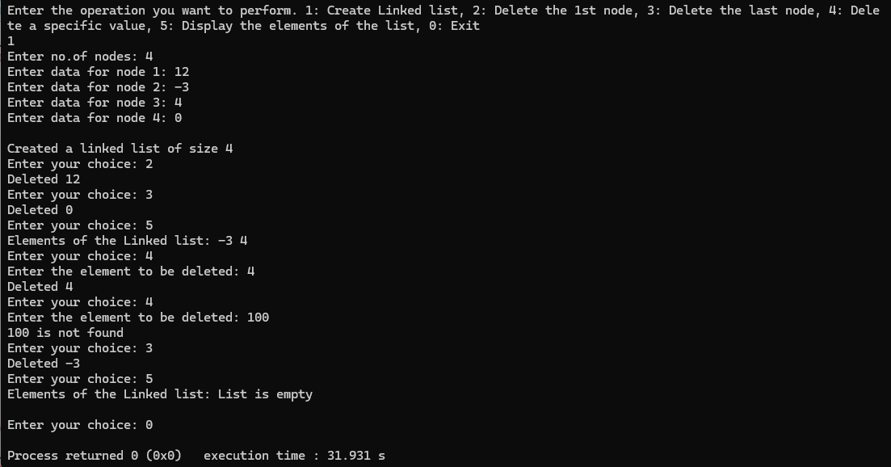

- Leetcode 203 (Remove Linked List Elements)
Code:
struct ListNode* removeElements(struct ListNode* head, int val) {
struct ListNode *curr=head,*prev=NULL;
struct ListNode *temp=malloc(sizeof(struct ListNode));
temp->val=0;
temp->next=head;
prev=temp;
curr=head;
while (curr!=NULL)
{
if (curr->val==val)
{
prev->next=curr->next;
free(curr);
curr=prev->next;
}
else
{
prev=curr;
curr=curr->next;
}
}
return temp->next;
}

Outputs:
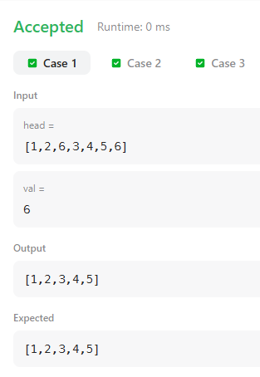

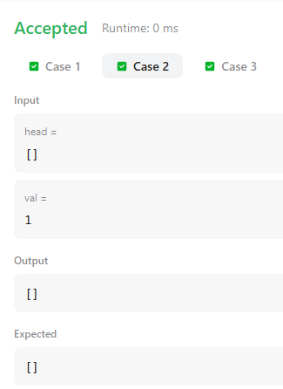

Lab program 6:
- WAP to Implement Single Link List with following operations: Sort the linked list, Reverse the linked list, Concatenation of two linked lists.
#include <stdio.h>
#include <stdlib.h>
struct node {
int data;
struct node *next;
};
void display(struct node *head) {
if (head == NULL) {
printf("List is empty\n");
return;
}
struct node *temp = head;
while (temp != NULL) {
printf("%d ", temp->data);
temp = temp->next;
}
printf("\n");
}
struct node * sortList(struct node *head) {
if (head == NULL) {
printf("List is empty\n");
return NULL;
}

struct node *i, *j;
int temp;

for (i = head; i->next != NULL; i = i->next) {
for (j = i->next; j != NULL; j = j->next) {
if (i->data > j->data) {
temp = i->data;
i->data = j->data;
j->data = temp;
}
}
}

printf("Linked list sorted\n");
return head;
}
struct node * reverseLinkedList(struct node *head) {
struct node *prev = NULL, *curr = head, *next = NULL;

if (head == NULL) {
printf("List is empty\n");
return NULL;
}

while (curr != NULL) {
next = curr->next;
curr->next = prev;
prev = curr;
curr = next;
}

printf("Linked list reversed\n");
return prev;
}
struct node * concatenateLists(struct node *head1, struct node *head2) {
if (head1 == NULL) return head2;
if (head2 == NULL) return head1;

struct node *temp = head1;

while (temp->next != NULL)
temp = temp->next;

temp->next = head2;

printf("Lists concatenated\n");
return head1;
}
struct node * createList(int n) {
if (n <= 0) {
printf("Number of nodes must be > 0\n");
return NULL;
}

struct node *head = NULL, *temp = NULL, *newNode;

for (int i = 1; i <= n; i++) {
newNode = malloc(sizeof(struct node));
if (!newNode) {
printf("Memory allocation failed\n");
return head;
}

printf("Enter data for node %d: ", i);
scanf("%d", &newNode->data);
newNode->next = NULL;

if (head == NULL)
head = newNode;
else
temp->next = newNode;

temp = newNode;
}

return head;
}
int main() {
int ch, n, m, n1, n2;
struct node *head = NULL, *head2 = NULL;

printf("1: Sort list\n2: Reverse list\n3: Concatenate lists\n0: Exit\n");

while (1) {
printf("\nEnter your choice: ");
scanf("%d", &ch);

if (ch == 0) break;

switch (ch) {
case 1:
printf("Enter number of nodes: ");
scanf("%d", &n);
head = createList(n);
head = sortList(head);
display(head);
break;

case 2:
printf("Enter number of nodes: ");
scanf("%d", &m);
head = createList(m);
head = reverseLinkedList(head);
display(head);
break;

case 3:
printf("Enter number of nodes in list 1 and 2: ");
scanf("%d %d", &n1, &n2);
head = createList(n1);
head2 = createList(n2);
head = concatenateLists(head, head2);
display(head);
break;

default:
printf("Invalid choice\n");
}
}

return 0;
}
Output:
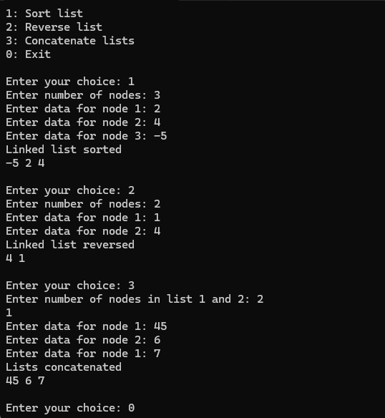

- WAP to Implement Single Link List to simulate Stack & Queue Operations.
#include <stdio.h>
#include <stdlib.h>

struct node {
int data;
struct node *next;
};

struct node *top = NULL;
struct node *front = NULL;
struct node *rear = NULL;

/* ---------------- STACK FUNCTIONS ---------------- */

void push(int data) {
struct node *newNode = malloc(sizeof(struct node));
if (!newNode) {
printf("Memory allocation failed\n");
return;
}

newNode->data = data;
newNode->next = top;
top = newNode;

printf("Inserted %d\n", data);
}

void pop() {
if (top == NULL) {
printf("Stack is empty\n");
return;
}

struct node *temp = top;
top = top->next;

printf("Deleted %d\n", temp->data);
free(temp);
}

void displayStack() {
if (top == NULL) {
printf("Stack is empty\n");
return;
}

struct node *temp = top;
printf("Stack elements: ");
while (temp != NULL) {
printf("%d ", temp->data);
temp = temp->next;
}
printf("\n");
}

/* ---------------- QUEUE FUNCTIONS ---------------- */

void enqueue(int data) {
struct node *newNode = malloc(sizeof(struct node));
if (!newNode) {
printf("Memory allocation failed\n");
return;
}

newNode->data = data;
newNode->next = NULL;

if (rear == NULL) {
front = rear = newNode;
} else {
rear->next = newNode;
rear = newNode;
}

printf("Inserted %d\n", data);
}

void dequeue() {
if (front == NULL) {
printf("Queue is empty\n");
return;
}

struct node *temp = front;
printf("Deleted %d\n", temp->data);

front = front->next;
if (front == NULL)
rear = NULL;

free(temp);
}

void displayQueue() {
if (front == NULL) {
printf("Queue is empty\n");
return;
}

struct node *temp = front;
printf("Queue elements: ");
while (temp != NULL) {
printf("%d ", temp->data);
temp = temp->next;
}
printf("\n");
}

/* ---------------- MAIN PROGRAM ---------------- */

int main() {
int ch;

printf("Enter 1 for Stack implementation, 2 for Queue implementation: ");
scanf("%d", &ch);

switch (ch) {
case 1:
printf("\n--- STACK IMPLEMENTATION ---\n");
printf("1: Push\n2: Pop\n3: Display\n0: Exit\n");

do {
printf("\nEnter your choice: ");
scanf("%d", &ch);

switch (ch) {
case 1: {
int x;
printf("Enter element to insert: ");
scanf("%d", &x);
push(x);
break;
}
case 2:
pop();
break;

case 3:
displayStack();
break;

case 0:
printf("Exiting stack menu\n");
break;

default:
printf("Invalid choice\n");
}

} while (ch != 0);
break;

case 2:
printf("\n--- QUEUE IMPLEMENTATION ---\n");
printf("1: Enqueue\n2: Dequeue\n3: Display\n0: Exit\n");

do {
printf("\nEnter your choice: ");
scanf("%d", &ch);

switch (ch) {
case 1: {
int x;
printf("Enter element to insert: ");
scanf("%d", &x);
enqueue(x);
break;
}
case 2:
dequeue();
break;

case 3:
displayQueue();
break;

case 0:
printf("Exiting queue menu\n");
break;

default:
printf("Invalid choice\n");
}

} while (ch != 0);
break;

default:
printf("Invalid choice — please enter 1 or 2\n");
}

return 0;
}

Output:
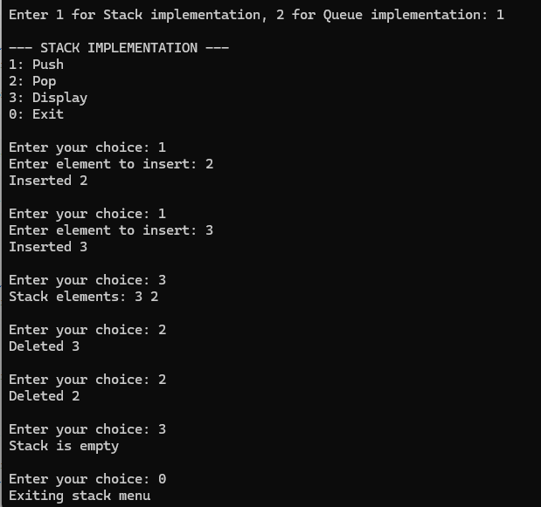
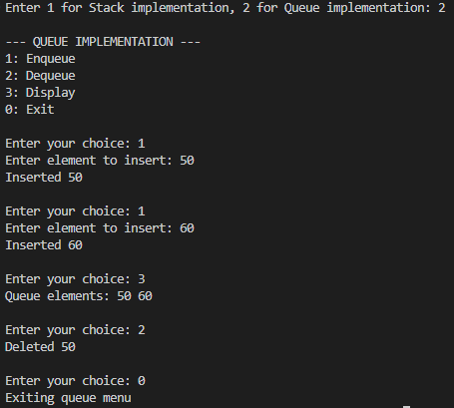

Lab program 7:
- WAP to Implement doubly link list with primitive operations:
a) Create a doubly linked list.
b) Insert a new node to the left of the node.
c) Delete the node based on a specific value
d) Display the contents of the list
#include<stdio.h>
#include<stdlib.h>
struct Node {
int data;
struct Node* next;
struct Node* prev;
};

struct Node* head = NULL,* tail = NULL;

void createList(int n){
int data,i;
struct Node* newNode;
for (i=1;i<=n;i++){
newNode=(struct Node*)malloc(sizeof(struct Node));
printf("Enter data for node %d: ",i);
scanf("%d",&data);
newNode->data=data;
newNode->next=newNode->prev=NULL;
if (head==NULL){
head=tail=newNode;
}
else{
newNode->prev=tail;
tail->next=newNode;
tail=newNode;
}
}
printf("Doubly Linked List created with %d nodes.\n",n);
}
void insertAtBeginning(int data){
struct Node* newNode = (struct Node*)malloc(sizeof(struct Node));
if (head==NULL){
head=tail=newNode;
return;
}
newNode->data = data;
newNode->next = head;
newNode->prev = NULL;
head->prev = newNode;
head = newNode;
}
void insertEnd(int data){
struct Node* newNode = (struct Node*)malloc(sizeof(struct Node));
if (head==NULL){
head=tail=newNode;
return;
}
newNode->data = data;
newNode->next = NULL;
newNode->prev = tail;
tail->next = newNode;
tail = newNode;
}
void insertPos(int data,int pos){
struct Node* newNode,* temp=head;
if (pos==1){
insertAtBeginning(data);
return;
}
newNode=(struct Node*)malloc(sizeof(struct Node));
newNode->data=data;
for (int i=1;i<pos-1 && temp!=NULL;i++){
temp=temp->next;
}
if (temp==NULL || temp->next==NULL){
insertEnd(data);
return;
}
newNode->next=temp->next;
newNode->prev=temp;
temp->next->prev=newNode;
temp->next=newNode;
}
void deleteFront(){
struct Node* temp=head;
if (head==NULL){
printf("List is empty\n");
return;
}
if (head==tail){
head=tail=NULL;
}
else{
head=head->next;
head->prev=NULL;
}
free(temp);
}
void deleteEnd(){
struct Node* temp=tail;
if (head==NULL){
printf("List is empty\n");
return;
}
if (head==tail){
head=tail=NULL;
}
else{
tail=tail->prev;
tail->next=NULL;
}
free(temp);
}
void deleteSpecific(int value){
struct Node* temp=head;
if (head==NULL){
printf("List is empty\n");
return;
}
while (temp!=NULL && temp->data!=value){
temp=temp->next;
}
if (temp==NULL){
printf("Value not found in the list\n");
return;
}
if (temp==head){
deleteFront();
}
else if (temp==tail){
deleteEnd();
}
else{
temp->prev->next=temp->next;
temp->next->prev=temp->prev;
free(temp);
}
}
void display(){
struct Node* temp=head;
if (head==NULL){
printf("List is empty\n");
return;
}
printf("Doubly Linked List: ");
while (temp!=NULL){
printf("%d<-> ",temp->data);
temp=temp->next;
}
printf("NULL\n");
}
int main(){
int n,choice,data,pos,value;
printf("\nMenu:\n1. Create List\n2. Insert at Position\n3. Delete Specific Value \n4. Display List\n5.Exit\n");
printf("Enter your choice: ");
scanf("%d",&choice);
while(choice!=5){
switch(choice){
case 1:
printf("Enter the number of nodes to create: ");
scanf("%d",&n);
createList(n);
break;
case 2:
printf("Enter data to insert: ");
scanf("%d",&data);
printf("Enter position to insert at: ");
scanf("%d",&pos);
insertPos(data,pos);
break;
case 3:
printf("Enter value to delete: ");
scanf("%d",&value);
deleteSpecific(value);
break;
case 4:
display();
break;
case 5:
printf("Exiting...\n");
break;
default:
printf("Invalid choice! Please try again.\n");
}
printf("Enter your choice: ");
scanf("%d",&choice);
}
return 0;
}
Output:
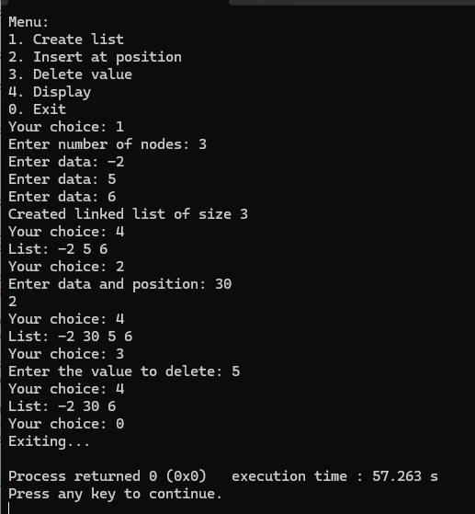

- Leetcode
Code:
bool hasCycle(struct ListNode *head) {
struct ListNode *slow = head;
struct ListNode *fast = head;

while (fast != NULL && fast->next != NULL) {
slow = slow->next; // move 1 step
fast = fast->next->next; // move 2 steps

if (slow == fast) {
return true; // cycle detected
}
}
return false;
}
Outputs:
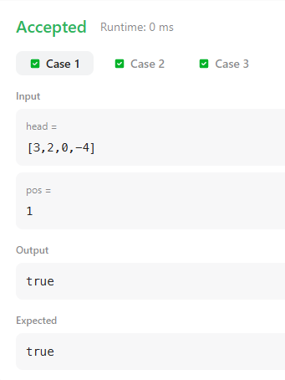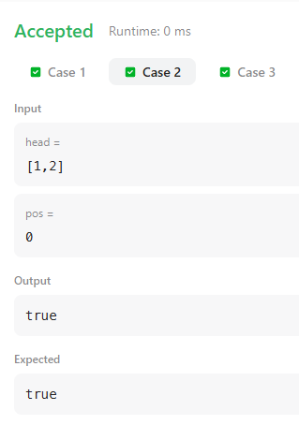

Lab program 8:
- Write a program
a) To construct a binary Search tree.
b) To traverse the tree using all the methods i.e., in-order, preorder and post order.
c) To display the elements in the tree.
#include<stdio.h>
#include<stdlib.h>
struct Node{
int data;
struct Node *left, *right;
};
struct Node * createNode(int val){
struct Node *newNode = (struct Node *)malloc(sizeof(struct Node));
newNode->data = val;
newNode->left = newNode->right = NULL;
return newNode;
}

struct Node* insert(struct Node* root, int val){
if(root == NULL){
return createNode(val);
}
if(val < root->data){
root->left = insert(root->left, val);
}
else if (val > root->data){
root->right = insert(root->right, val);
}
return root;
}

void inorder(struct Node* root){
if (root == NULL) return;
inorder(root->left);
printf("%d ", root->data);
inorder(root->right);
}

void preorder(struct Node* root){
if (root == NULL) return;
printf("%d ", root->data);
preorder(root->left);
preorder(root->right);
}

void postorder(struct Node* root){
if (root == NULL) return;
postorder(root->left);
postorder(root->right);
printf("%d ", root->data);
}

void display(struct Node *root){
printf("BST Elements:\n");
inorder(root);
printf("\n");
}

int main(){
struct Node *root=NULL;
int choice, val;
while(1){
printf("1. Insert\n2. Inorder Traversal\n3. Preorder Traversal\n4. Postorder Traversal\n5. Display BST\n6. Exit\n");
printf("Enter your choice: ");
scanf("%d", &choice);
switch(choice!=6){
case 1:
printf("Enter value to insert: ");
scanf("%d", &val);
root = insert(root, val);
break;
case 2:
printf("Inorder Traversal: ");
inorder(root);
printf("\n");
break;
case 3:
printf("Preorder Traversal: ");
preorder(root);
printf("\n");
break;
case 4:
printf("Postorder Traversal: ");
postorder(root);
printf("\n");
break;
case 5:
display(root);
break;
case 6:
printf("Exit\n");
default:
printf("Invalid choice!\n");
}
}
}
Output:
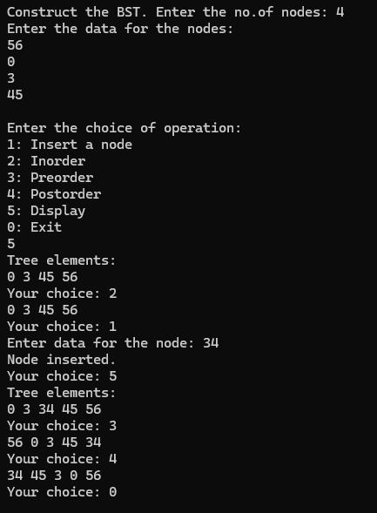

- Leetcode
Code:
struct TreeNode* mergeTrees(struct TreeNode* root1, struct TreeNode* root2) {
if (root1 == NULL && root2 == NULL)
return NULL;
if (root1 == NULL)
return root2;
if (root2 == NULL)
return root1;

struct TreeNode *root3 = (struct TreeNode*) malloc(sizeof(struct TreeNode));
root3->val = root1->val + root2->val;
root3->left = mergeTrees(root1->left, root2->left);
root3->right = mergeTrees(root1->right, root2->right);

return root3;
}
Outputs:
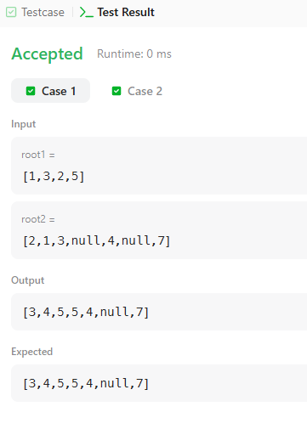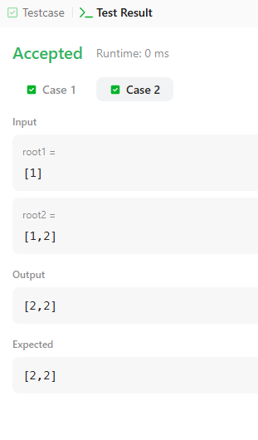

Lab Program 9:
- Write a program to traverse a graph using BFS method.
Code:
#include <stdio.h>
#define MAX 20

int graph[MAX][MAX],visited[MAX],n;

void BFS(int start)
{
int queue[MAX],front=0,rear=0;
visited[start]=1;
queue[rear++]=start;

while (front<rear)
{
int node=queue[front++];
printf("%d ",node);
for (int i=0;i<n;i++)
{
if (graph[node][i]==1 && !visited[i])
{
visited[i]=1;
queue[rear++]=i;
}
}
}
}

int main()
{
int start;
printf("Enter the no.of vertices: ");
scanf("%d",&n);
printf("Enter the adjacency matrix:\n");
for (int i=0;i<n;i++)
{
for (int j=0;j<n;j++)
{
scanf("%d",&graph[i][j]);
}
visited[i]=0;
}
printf("Enter the starting vertex: ");
scanf("%d",&start);
printf("BFS Traversal: ");
BFS(start);
return 0;
}
Output:
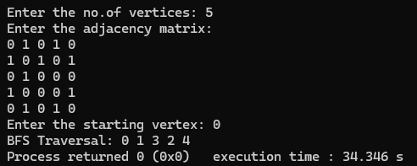

- Write a program to check whether a given graph is connected or not using the DFS method.
Code:
#include <stdio.h>
#define MAX 20

int graph[MAX][MAX],visited[MAX],n;

void DFS(int v)
{
visited[v]=1;
printf("%d ",v);
for (int i=0;i<n;i++)
{
if (graph[v][i]==1 && !visited[i])
DFS(i);
}
}

int main()
{
int start;
printf("Enter the no.of vertices: ");
scanf("%d",&n);
printf("Enter the adjacency matrix:\n");
for (int i=0;i<n;i++)
{
for (int j=0;j<n;j++)
{
scanf("%d",&graph[i][j]);
}
}
for (int i=0;i<n;i++)
{
visited[i]=0;
}
printf("Enter the starting vertex: ");
scanf("%d",&start);
printf("DFS Traversal: ");
DFS(start);
return 0;
}
Output:
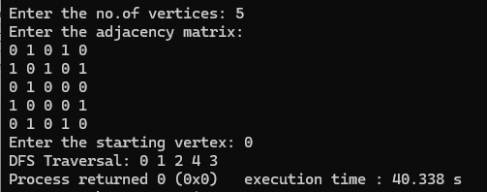

Lab Program 10:
Given a File of N employee records with a set K of Keys(4-digit) which uniquely determine the records in file F. Assume that file F is maintained in memory by a Hash Table (HT) of m memory locations with L as the set of memory addresses (2-digit) of locations in HT. Let the keys in K and addresses in L are integers. Design and develop a Program in C that uses Hash function H: K -> L as H(K)=K mod m (remainder method), and implement hashing technique to map a given key K to the address space L. Resolve the collision (if any) using linear probing.
Code:
# include <stdio.h>
# define MAX 20

int hashTable[MAX];
int m;
void insert(int key)
{
int index=key%m;
if (hashTable[index]==-1)
{
hashTable[index]=key;
}
else
{
int i=1;
while (hashTable[(index+1)%m]!=1)
{
i++;
}
hashTable[(index+1)%m]=key;
}
}

void display()
{
printf("\nHash Table\n");
for (int i=0;i<m;i++)
{
if (hashTable[i]!=-1)
printf("Address %d: %d\n",i,hashTable[i]);
else
printf("Address %d: Empty\n",i);
}
}

int main()
{
int n,key;
printf("Enter the size of the hash table: ");
scanf("%d",&m);
printf("Enter the no.of employee records: ");
scanf("%d",&n);
for (int i=0;i<m;i++)
{
hashTable[i]=-1;
}
printf("Enter %d employee keys (4-digit):\n",n);

for (int i=0;i<n;i++)
{
scanf("%d",&key);
insert(key);
}

display();
return 0;
}
Output:
